Create and Inspect a Docker Volume for Backup
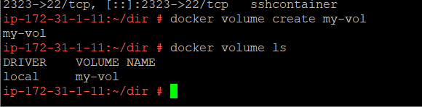
No files before mounting
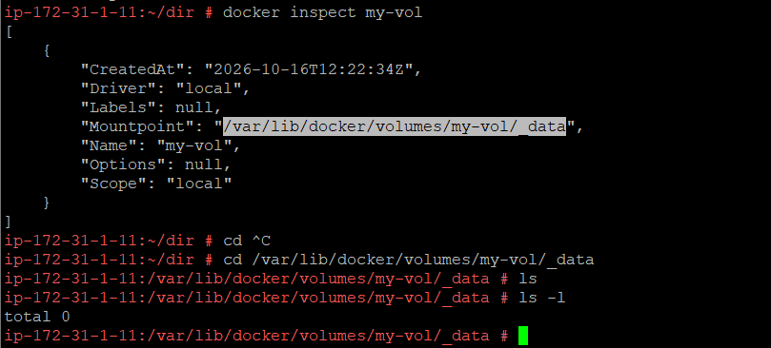
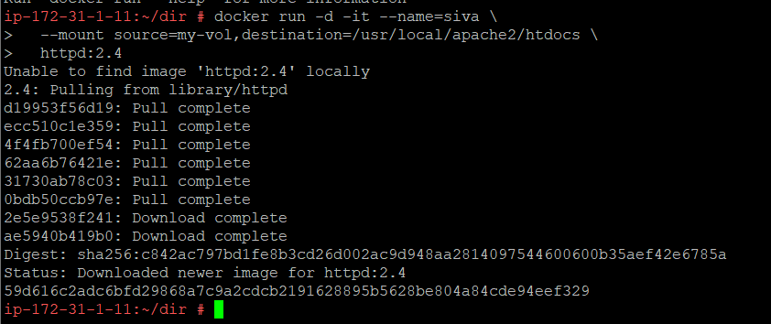
Now the files are mounted
